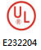
WMZ12A (Ⅳ) Series

PTC Thermistors正温度系数热敏电阻器
- For Thermal Protection / Sensors用于过热保护/极限温度传感器

■ GENERAL 概述
WMZ12A(Ⅳ) series PTC thermistors is a temperature indicator for indicating any overheating of fan motors and power transistors, thyristors in the power sources etc.
WMZ12A(Ⅳ)系列PTC热敏电阻器作为温度控制器应用于风扇马达和晶体管、可控硅等电源电路温度控制、过热保护。

■ PART NUMBERING 产品编号

WMZ12A (Ⅳ) | - | 84 | HV | 102 | N | L | S | B | 4
⑴ ⑵ ⑶ ⑷ ⑸ ⑹ ⑺ ⑻ ⑼

⑴ Series系列: WMZ12A (Ⅳ) – WEILIN-ZHONGHAO PTC Thermistors For Thermal Protection / Sensors
偉林–中昊过热保护/ 极限温度传感器系列PTC热敏电阻
⑵ Rated-Action Temperature T_{NF}标称动作温度: 50 - 50℃ 100- 100℃ 130 - 130℃
⑶ Max. Diameter外径D_{max}: HV / A – Φ6.5 S – Φ4.5 L – Φ5.5
⑷ Rated Zero Power Resistance额定零功率电阻R_{N}: 102 – 1,200Ω 50 - 50Ω
⑸ Tolerance of Resistance 电阻允差: N - ±30% P-±50% V -±25% M - ±20% K - ±10% X - Else其它
⑹ Fixed type固定方式: L - Leads引线 F - Fixed Flake 固定片
⑺ Coating Material 包封材料: S - Silicone 硅树脂 N - No Coating无包封 P - PF Resin 酚酫树脂 E - Epoxy 环氧树脂
⑻ Packing 包装: B - Bulk 散装 A - Ammo 条带 R - Reel 盘带
⑼ Leads Length 引线长度4: 4mm (10:10mm)
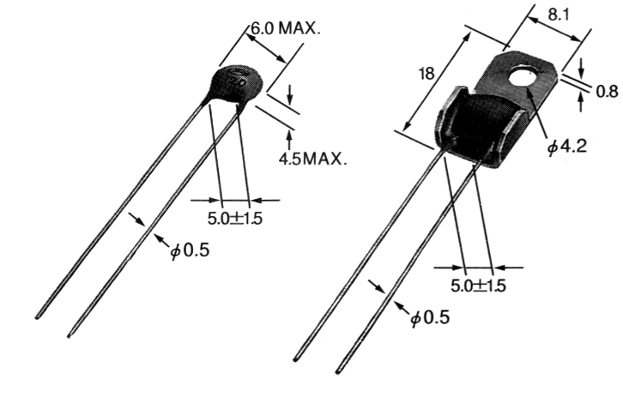
Leads Type Fixed Flake
引线 固定片

■ SPECIFICATION S TABLE规格表

No.  序号 | Part No.  产品编号 | Rated Zero Power  Resistance  额定零功率电阻  R_{N} (Ω) | Rated-Action Temperature  标称动作温度  T_{NF} (℃ ) | Low Temp. Indication  下限温控点 |  | High Temp. Indication  上限温控点
 |  |  |  | T_{L} (℃) | R_{L} (Ω) | T_{H} (℃) | R_{H} (Ω)
01 | WMZ12A(Ⅳ)-60S80PLSB | 40 ~ 120 | 60 | 55 | ≤ 570 | 65 | > 570
02 | WMZ12A(Ⅳ)-70S80PLSB | 40 ~ 120 | 70 | 65 | ≤ 570 | 75 | > 570
03 | WMZ12A(Ⅳ)-80S80PLSB | 40 ~ 120 | 80 | 75 | ≤ 570 | 85 | > 570
04 | WMZ12A(Ⅳ)-90S80PLSB | 40 ~ 120 | 90 | 85 | ≤ 550 | 95 | ≥1,100
05 | WMZ12A(Ⅳ)-100S80PLSB | 40 ~ 120 | 100 | 95 | ≤ 550 | 105 | ≥1,100
06 | WMZ12A(Ⅳ)-110S80PLSB | 40 ~ 120 | 110 | 105 | ≤ 550 | 115 | ≥1,100
07 | WMZ12A(Ⅳ)-120S80PLSB | 40 ~ 120 | 120 | 115 | ≤ 550 | 125 | ≥1,100
08 | WMZ12A(Ⅳ)-130S80PLSB | 40 ~ 120 | 130 | 125 | ≤ 550 | 135 | ≥1,100
09 | WMZ12A(Ⅳ)-140S80PLSB | 40 ~ 120 | 140 | 135 | ≤ 550 | 145 | ≥1,100
10 | WMZ12A(Ⅳ)-150S80PLSB | 40 ~ 120 | 150 | 145 | ≤ 550 | 155 | ≥1,100
11 | WMZ12A(Ⅳ)-160S80PLSB | 40 ~ 120 | 160 | 155 | ≤ 550 | 165 | ≥1,100
12 | WMZ12A(Ⅳ)-170S80PLSB | 40 ~ 120 | 170 | 765 | ≤ 550 | 175 | ≥1,100
13 | WMZ12A(Ⅳ)-180S80PLSB | 40 ~ 120 | 180 | 175 | ≤ 550 | 185 | ≥1,100
14 | WMZ12A(Ⅳ)-40L122M LSB | 1,200±20% | 40 | 25 | 1,200±20% | 40 | ≥4.2K
15 | WMZ12A(Ⅳ)-40L302M LSB | 3,000±20% | 40 | 25 | 3,000±20% | 40 | ≥9.0K
16 | WMZ12A(Ⅳ)-40L322M LSB | 3,200±20% | 40 | 25 | 3,200±20% | 40 | ≥11K
17 | WMZ12A(Ⅳ)-40L702M LSB | 7,000±20% | 40 | 25 | 7,000±20% | 40 | ≥22K
18 | WMZ12A(Ⅳ)-83HV102NLEB | 1,000±20% | 83 | 78 | ≤ 50K | 87 | ≥100K
19 | WMZ12A(Ⅳ)-88HV102NLEB | 1,000±20% | 88 | 84 | ≤ 50K | 91 | ≥100K

