

WMF52 Series

Bead Type NTC Thermistors滴珠型负温度系数热敏电阻器
- For Temperature Sensing 用于温度探测及控制

■ GENERAL 概述
WMF52系列负温度热敏电阻器体积小、精度高、响应快，互换、一致性好，能长时间稳定工作。主要应用于电烤箱、电饭煲和空调、暖气、体温计、汽车、台历等电子设备的温度探测。
尤其是新开发的硅树脂包封型产品能在高温（如250℃）、高湿（如95%）环境条件下稳定、可靠地工作，与玻封型产品相比，在性能、成本方面均享有明显优势。

WMF52 Series NTC thermistors are ultra small size, high precision, rapid response, good quality of coherence and interchange and reliable. WMF52 series are used in temperature sensing of the electronic equipment such as ovens and cooker, air conditions, thermometers, cars and calendars. Especially, the silicone type－ a new product which is coated with a special kind of silicone resin can operate reliably and steady in the environments of high temperature (e.g.250℃) and high moisture ( e.g.95%RH) and has obvious advantages in characteristics and cost than the glass type.

■ PART NUMBERING 产品编号

WMF52 | A | - | 103 | F |  | 3950 | G |  | B | - | R
⑴ ⑵ ⑶ ⑷ ⑸ ⑹ ⑺ ⑻

⑴ Series系列：WMF52系列
⑵ Lead wire material: A-tinned steel wire, B-Enamelled Cu wire, C-PTFE wire, D-PVC wire, E-Tinned copper brass wire
引出端材料类型： A-镀锡钢线/铜线 B-漆包线 C-铁氟龙线 D-PVC线 E-镀锡钢带/铜带
⑶ Rated Zero Power Resistance & Tol. 额定零功率电阻及允差：103-10KΩ 502-5KΩ 2.5K – 2.5KΩ
⑷ Tolerance允差范围：F-±1% G-±2% H-±3% J-±5% K-±10%
⑸ B value B值：3,100 - 3,100ºK 4,050 - 4,050ºK
⑹ B value tolerance B值允差： F-±1% G-±2% H-±3%
⑺ Packing Type包装形式：B - Bulk 散装Special Code (RoHS) 特别代码：
⑻ R-Compliance with RoHS ( e.g.: Pb Free ) 符合RoHS要求 ( 如: 不含铅 )
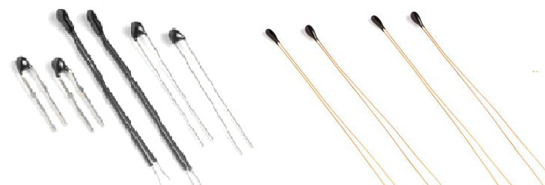

WMF52A/C/D/E WMF52B
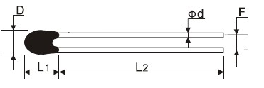

A-镀锡钢线/铜线

代号 | D | L₁ | L₂ | d±0.05 | F±0.5
A1 | max 2.2 | max 3.5 | Min25 | 0.4 | 2.0
A2 | max 2.8 | max 3.5 | Min25 | 0.4 | 2.0
A3 | max 3.0 | max 4.0 | Min25 | 0.4 | 2.0
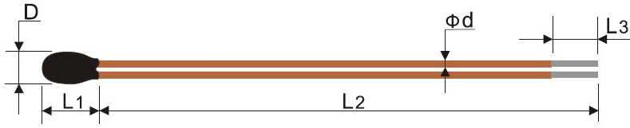

B-漆包线

代号 | D | L1 | L2 | L3±1.0 | d±0.05
B | max 1.4 | max 4.0 | 85~90 | 3 | 0.15 / 0.2

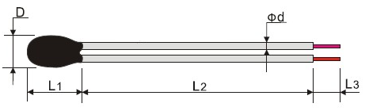

- 铁氟龙线

代号 | D | L1 | L2 | L3±1.0 | d±0.05
C1 | max 3.5 | max 5.0 | min 5.0 | 3.0 / 5.0 | 0.8
C2 | max 3.0 | max 5.0 | min 5.0 | 3.0 / 5.0 | 0.65

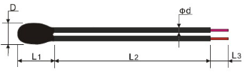

D-PVC线

代号 | D | L1 | L2 | L3±1.0 | d±0.05
D1 | max 3.5 | max 5.0 | min 5.0 | 3.0 / 5.0 | 0.8
D2 | max 3.0 | max 5.0 | min 5.0 | 3.0 / 5.0 | 0.65

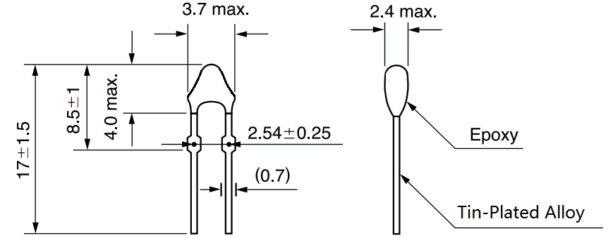

E-镀锡钢片/铜片

■ SPECIFICATION S TABLE规格表

序号  No. | 产品编号  Part No | 额定零功率电阻(R25)  Rated Zero Power Resistance |  | B值(25℃/50℃)  B Value(K) |  | 热耗散系数δ (mw/℃)  Thermal Dissipation  Constant | 额定功率  （mw） | 热时间常数τ(s)  Thermal Time  Constant | 工作温度(℃)  Operating  Temperature
序号  No. | 产品编号  Part No | 电阻值  （KΩ） | 允差  （±%） | 标称值  （K） | 允差  （±%）
1 | WMF52¨-202□4000□ | 2K | 1,2,3,5,10 | 4000 | 1,2,3 | ≥2.0 | ≤50 | ≤12 | -40-+125
2 | WMF52¨-2.55□3740□ | 2.55K | 1,2,3,5,10 | 3740
3 | WMF52¨-202□3930□ | 2K | 1,2,3,5,10 | 39300
4 | WMF52¨-202□3483□ | 2K | 1,2,3,5,10 | 3483
5 | WMF52¨-472□3950□ | 4.7K | 1,2,3,5,10 | 3950
6 | WMF52¨-502□3470□ | 5K | 1,2,3,5,10 | 3470
7 | WMF52¨-502□3950□ | 5K | 1,2,3,5,10 | 3950
8 | WMF52¨-802□3780□ | 8K | 1,2,3,5,10 | 3780
9 | WMF52¨-103□3270□ | 10K | 1,2,3,5,10 | 3270
10 | WMF52¨-103□3435□ | 10K | 1,2,3,5,10 | 3435
11 | WMF52¨-103□3470□ | 10K | 1,2,3,5,10 | 3470
12 | WMF52¨-103□3600□ | 10K | 1,2,3,5,10 | 3600
13 | WMF52¨-103□3950□ | 10K | 1,2,3,5,10 | 3950
14 | WMF52¨-103□3977□ | 10K | 1,2,3,5,10 | 3977
15 | WMF52¨-103□4100□ | 10K | 1,2,3,5,10 | 4100
16 | WMF52¨-153□3680□ | 15K | 1,2,3,5,10 | 3680
17 | WMF52¨-153□4100□ | 15K | 1,2,3,5,10 | 4100
18 | WMF52¨-203□4150□ | 20K | 1,2,3,5,10 | 4150
19 | WMF52¨-303□3950□ | 30K | 1,2,3,5,10 | 3950
20 | WMF52¨-40.03□3900□ | 40.03K | 1,2,3,5,10 | 3900
21 | WMF52¨-473□3950□ | 47K | 1,2,3,5,10 | 3950
22 | WMF52¨-473□3990□ | 47K | 1,2,3,5,10 | 3990
23 | WMF52¨-503□3950□ | 50K | 1,2,3,5,10 | 3950
24 | WMF52¨-503□3990□ | 50K | 1,2,3,5,10 | 3990
25 | WMF52¨-104□3950□ | 100K | 1,2,3,5,10 | 3950
26 | WMF52¨-104□4200□ | 100K | 1,2,3,5,10 | 4200
27 | WMF52¨-154□4370□ | 150K | 1,2,3,5,10 | 4370
28 | WMF52¨-402□3100□ | 4K | 1,2,3,5,  10 | 4000 | 1,2,3 | ≥0.7 | ≤3.5 | ≤6 | -40-+125
29 | WMF52¨-103□3435□ | 10K | 1,2,3,5,  10 | 3435
30 | WMF52¨-103□3250□ | 10K | 1,2,3,5,  10 | 3250
31 | WMF52¨-303□3760□ | 30K | 1,2,3,5,  10 | 3760
32 | WMF52¨-403□3525□ | 40K | 1,2,3,5,  10 | 3525
33 | WMF52¨-413□3435□ | 41K | 1,2,3,5,  10 | 3435
34 | WMF52¨-503□4055□ | 50K | 1,2,3,5,  10 | 4055
35 | WMF52¨-593□3617□ | 59K | 1,2,3,5,  10 | 3617
36 | WMF52¨-833□4013□ | 83K | 1,2,3,5,  10 | 4013
37 | WMF52¨-104□4132□ | 100K | 1,2,3,5,  10 | 4132
38 | WMF52¨-226□4021□ | 226 | 1,2,3,5,  10 | 4021
39 | WMF52¨-232□4274□ | 232 | 1,2,3,5,  10 | 4274

1-□引线材料代号 2-□代表阻值公差代号 3-□代表B值公差代号

