

WMF58 Series

Glass Package Type NTC Thermistors
玻璃封装型负温度系数热敏电阻器
- For Temperature Sensing用于温度探测及控制

■ GENERAL 概述
WMF58系列负温度热敏电阻器体积小、热感应快、灵敏度高、能在高温和高湿等恶劣环境下长时间稳定工作。
主要应用于电磁炉、电压力锅、电饭煲、电烤箱、消毒柜、微波炉等家用电器的温度控制及温度探测；工业、医疗、环保、气象、食品加工设备的温度控制和探测。

WMF58 series negative temperature thermistors have small volume, fast thermal induction, high sensitivity, and can work stably in high temperature and high humidity for a long time.
It is mainly used for temperature control and detection of home appliances such as induction cooker, pressure cooker, rice cooker, electric oven, sterilizer, microwave oven, etc.

■ PART NUMBERING 产品编号

WMF58 | A | - | 103 | F | 3950 | G |  | B | - | R
⑴ ⑵ ⑶ ⑷ ⑸ ⑹ ⑺ ⑻

⑴ Series系列：WMF58系列
⑵ Eductor typel: A-Axial lead heterotopy, B-Same End of radial lead
引出端类型：A-轴向引线异端 B-径向引线同端
⑶ Rated Zero Power Resistance & Tol. 额定零功率电阻及允差：103-10KΩ 502-5KΩ 2.5K – 2.5KΩ
⑷ Tolerance: 允差范围：F-±1% G-±2% H-±3% J-±5% K-±10%
⑸ B value B值：3,100 - 3,100ºK 4,050 - 4,050ºK
⑹ B value tolerance B值允差： F-±1% G-±2% H-±3%
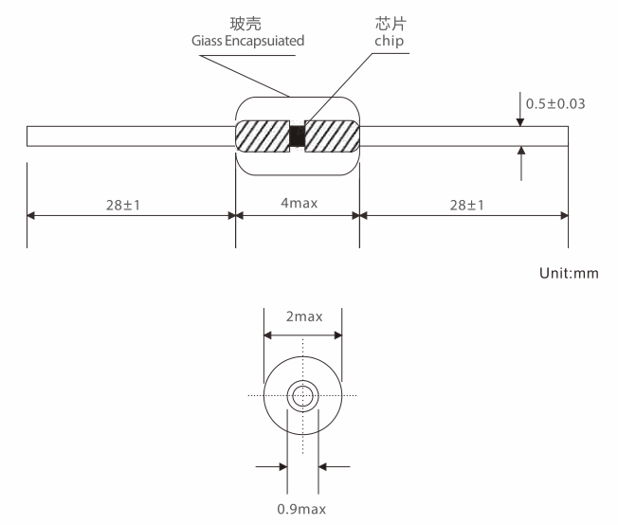
⑺ Packing Type包装形式：B - Bulk 散装Special Code (RoHS) 特别代码：
⑻ R-Compliance with RoHS ( e.g.: Pb Free ) 符合RoHS要求 ( 如: 不含铅 )
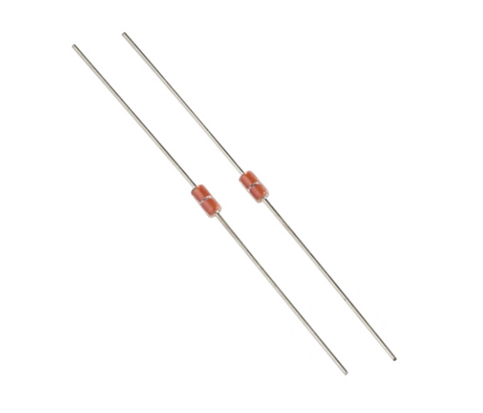

WMF58A

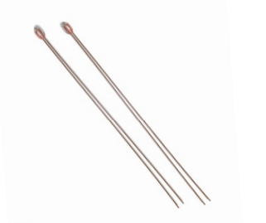
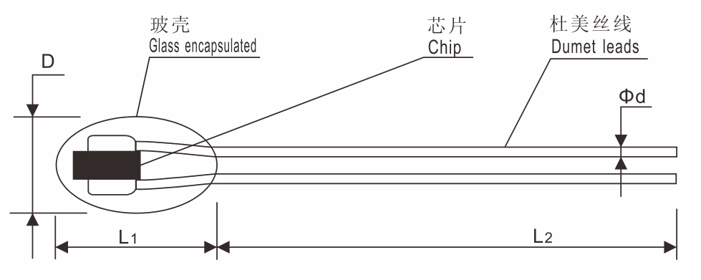

WMF58B

代号 | D | L₁ | L₂±5 | d±0.05
B1 | 1.3±0.2 | Max 3.2 | 65 | 0.25
B2 | 1.8±0.2 | 3.4±0.5 | 65 | 0.25

■ SPECIFICATION S TABLE规格表

序号  No. | 产品编号  Part No | 额定零功率电阻(R25)  Rated Zero Power Resistance |  | B值(25℃/50℃)  B Value(K) |  | 热耗散系数δ (mw/℃)  Thermal Dissipation  Constant | 额定功率  （mw） | 热时间常数τ(s)  Thermal Time  Constant | 工作温度(℃)  Operating  Temperature
序号  No. | 产品编号  Part No | 电阻值  （KΩ） | 允差  （±%） | 标称值  （K） | 允差  （±%）
1 | WMF58A-202¨3839¨ | 2K | 1,2,3,5 | 3839 | 1,2,3 | ≥2.0 | ≤50 | ≤12 | -40-+250
2 | WMF58A-502¨3470¨ | 5K | 1,2,3,5 | 3470
3 | WMF58A-502¨3950¨ | 5K | 1,2,3,5 | 3950
4 | WMF58A-103¨3380¨ | 10K | 1,2,3,5 | 3380
5 | WMF58A-103¨3470¨ | 10K | 1,2,3,5 | 3470
6 | WMF58A-103¨3600¨ | 10K | 1,2,3,5 | 3600
7 | WMF58A-103¨3700¨ | 10K | 1,2,3,5 | 3700
8 | WMF58A-103¨3950¨ | 10K | 1,2,3,5 | 3950
9 | WMF58A-103¨3975¨ | 10K | 1,2,3,5 | 3975
10 | WMF58A-103¨4100¨ | 10K | 1,2,3,5 | 4100
11 | WMF58A-203¨3950¨ | 20K | 1,2,3,5 | 3950
12 | WMF58A-303¨3950¨ | 30K | 1,2,3,5 | 3950
13 | WMF58A-233¨4200¨ | 23K | 1,2,3,5 | 4200
14 | WMF58A-473¨3950¨ | 47K | 1,2,3,5 | 3950
15 | WMF58A-503¨3950¨ | 50K | 1,2,3,5 | 3950
16 | WMF58A-503¨4050¨ | 50K | 1,2,3,5 | 4050
17 | WMF58A-104¨3899¨ | 100K | 1,2,3,5 | 3899
18 | WMF58A-104¨3930¨ | 100K | 1,2,3,5 | 3930
19 | WMF58A-104¨3950¨ | 100K | 1,2,3,5 | 3950
20 | WMF58A-104¨3990¨ | 100K | 1,2,3,5 | 3990
21 | WMF58A-104¨4200¨ | 100K | 1,2,3,5 | 4200
22 | WMF58A-204¨3899¨ | 200K | 1,2,3,5 | 3899
23 | WMF58A-204¨4200¨ | 200K | 1,2,3,5 | 4200
24 | WMF58A-204¨4260¨ | 200K | 1,2,3,5 | 4260
25 | WMF58A-504¨4260¨ | 500K | 1,2,3,5 | 4260
26 | WMF58A-504¨4050¨ | 500K | 1,2,3,5 | 4050
27 | WMF58B-103¨3950¨ | 10K | 1,2,3,5 | 3950
28 | WMF58B-103¨3435¨ | 10K | 1,2,3,5 | 3435
29 | WMF58B-503¨3950¨ | 50K | 1,2,3,5 | 3950
30 | WMF58B-503¨4036¨ | 50K | 1,2,3,5 | 4036
31 | WMF58B-104¨3950¨ | 100K | 1,2,3,5 | 3950
32 | WMF58B-104¨4200¨ | 100K | 1,2,3,5 | 4200
33 | WMF58B-204¨3899¨ | 200K | 1,2,3,5 | 3899

1-□代表阻值公差代号 2-□代表B值公差代号

